Introduction to Computers and Programming in C
  - Computer Science and Engineering
Name :- Sanyam Kochar
Enrollment number:- 2345920021


INDEX
S No. | Objective | Date | Signature | Remarks
1(A) | To Add Two Numbers.
(B) | To Add Three Numbers.
2(A) | To Find Area Of Circle.
(B) | To Calculate Simple Interest.
3 | To Print A Block F Using Hash(#).
4 | Program That Accepts 2 Item’s Weight & Number Of Purchase & Calculate Average Value Of Items .
5(A) | To Swap 2 Variables Using 3rd Variable.
(B) | To Swap 2 Variables Without Using 3rd Variable.
6(A) | To Convert A Given Integer(In Seconds) To Hours,Minutes,Seconds.
(B) | To Convert Specified Days Into Years,Weeks And Days.
(C) | To Check Whether A Number Is Even Or Odd
7 | To Check Whether A Given Year Is Leap Year Or Not
8(A) | To Check Whether A Triangle Is Equilateral, Scalene Or Isosceles.
(B) | To Check Whether A Triangle Is Right Triangle, Obtuse, Acute Angles.
9 | To Convert Temp. From Fahrenheit To Celsius And Celsius To Fahrenheit.
10(A) | To Check Whether A Character Is An Alphabet, Digit Or Special Character.
(B) | To Check Whether An Alphabet Is Vowel Or Consonant.
11(A) | To Find Smallest Of 2 Numbers.
(B) | To Find Largest Of 3 Numbers.
12 | To Implement Simple Calculator.
13 | To Calculate The Root Of A Quadratic Equation.
14 | To Accept A Coordinate Point In A Xy Coordinate System And Determine In Which Quadrant The Point Lies.
15 | To Find Gross Salary Of An Employee If Da Is 40% Of Basic Salary And Hra Is 20% Of Basic Salary.
16 | To Calculate And Print The Electricity Bill Of A Given Costumer.
17 | To Accept The Number Of Days The Member Is Late To Return The Book.
18 | To Find The Factorial Of Any Number.
19 | To Print Fibonacci Sequence.
20 | To Accept An Integer And Find Sum Of Digits.
21 | To Accept An Integer And Find Reverse Of This Number And Check This Number For Palindrome.
22 | To Check A Number Is Amstrong Or Not.
23 | To Check A Number Is Perfect Or Not.
24 | To Find The Sum Of Series.
25 | To Check A Number Is Prime Or Not.
26 | To Find The Sum Of Series.
27 | To Find The Sum Of Series.
28 | To Find The Sum Of Series.
29 | To Find The Sum Of Series.
30 | To Convert Binary Number To Decimal Number.
31 | To Find The Sum Of Series.
32 | To Print The Pattern.
33 | To Print The Pattern.
34 | To Print The Pattern.
35 | To Print The Pattern.
36 | To Print The Pattern.
37 | To Print The Pattern.
38 | To Print The Pattern.
39 | To Print The Pattern.
40 | To Print The Pattern.
41 | To Print The Pattern.
42 | To Print The Pattern.
43 | To Print The Pattern.
44 | To Print The Pattern.
45 | To Print All Prime Numbers In A Given Range.
46 | To Convert Decimal Number Into Binary.
47 | To Find Sum, Average, Max And Min From A List Of N Numbers.

1.(a) To Add two numbers.
#include <stdio.h>
int main()
{
int x, y, sum;
printf("Enter two numbers: ");
scanf("%d%d",&x,&y);
sum=x+y;
printf("Sum of the numbers is: %d", sum);
return 0;
}
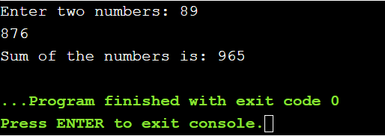

1.(b) To add three numbers.
#include <stdio.h>
int main()
{
int x, y, z, sum;
printf("Enter three numbers: ");
scanf("%d%d%d",&x,&y,&z);
sum=x+y+z;
printf("Sum of the numbers is: %d", sum);
return 0;
}
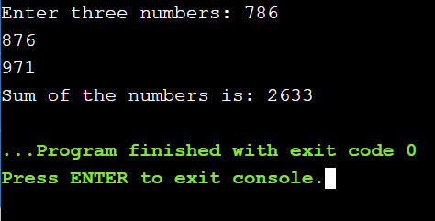

2.(a) To find area of circle.
#include <stdio.h>
int main()
{
int r, area;
printf("Enter the radius: ");
scanf("%d",&r);
area=3.14*r*r;
printf("Area of circle is: %d", area);
return 0;
}
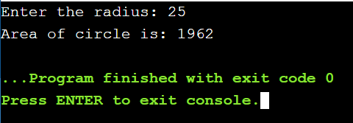

2.(b) To calculate simple interest.
#include <stdio.h>
int main()
{
int P, R, T, SI;
printf("Enter the values of P, R, T: ");
scanf("%d%d%d",&P,&R,&T);
SI=(P*R*T)/100;
printf("Te simple interest is: %d", SI);
return 0;
}

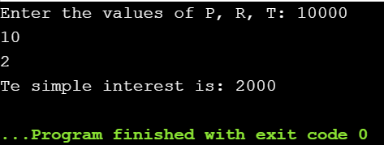

3. To print a block F using hash(#).
#include <stdio.h>
int main()
{
printf("#####\n");
printf("#\n");
printf("####\n");
printf("#\n");
printf("#\n");
printf("#\n");
return 0;
}

4. Program that accepts 2 item’s weight & number of purchase & calculate average value of the items.
#include <stdio.h>
int main()
{
float w1, n1, w2, n2, result;
printf("Weight of Item1: ");
scanf("%f", &w1);
printf("No. of item1: ");
scanf("%f", &n1);
printf("Weight of Item2: ");
scanf("%f", &w2);
printf("No. of item2: ");
scanf("%f", &n2);
result = ((w1 * n1) + (w2 * n2)) / (n1 + n2);
printf("Average Value = %f\n", result);
return 0;
}

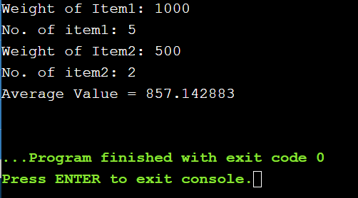

5.(a) To swap 2 variables using 3rd variable.
#include <stdio.h>
int main()
{
double first, second, temp;
printf("Enter first number: ");
scanf("%lf", &first);
printf("Enter second number: ");
scanf("%lf", &second);
temp = first;
first = second;
second = temp;
printf("\nAfter swapping, firstNumber = %.2lf\n", first);
printf("After swapping, secondNumber = %.2lf", second);
return 0;
}

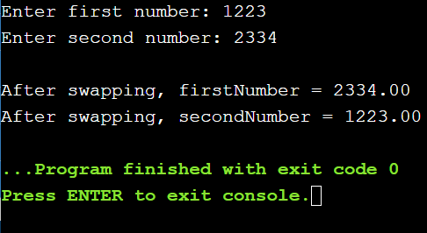

5(b). To swap 2 variables without using 3rd variable.
#include <stdio.h>
int main()
{
int x, y;
printf("Enter the numbers: \n");
scanf("%d%d",&x,&y);
x=x+y;
y=x-y;
x=x-y;
printf("\nAfter swapping the values will be: %d %d",x,y);
return 0;
}
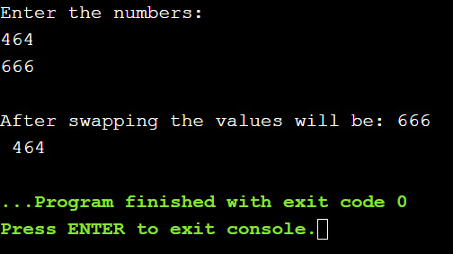

6(a). To convert a given integer (in seconds) to hours, minutes, seconds.
#include <stdio.h>
int main()
{
int sec, h, m, s;
printf("Input seconds: ");
scanf("%d", &sec);
h = (sec/3600);
m = (sec/60);
s = (sec);
printf("H:M:S - %d:%d:%d\n",h,m,s);
return 0;
}
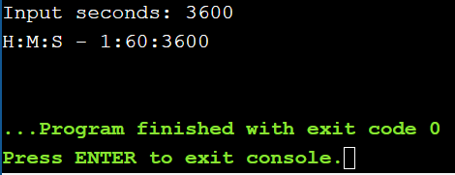

6(b). To convert specified days into years, weeks and days. No. of days: 1095.
#include <stdio.h>
int main()
{
int days, years, weeks;
days = 1095;
years = (days/365);
weeks = (days/7);
days = (days);
printf("Years: %d\n", years);
printf("Weeks: %d\n", weeks);
printf("Days: %d \n", days);
return 0;
}
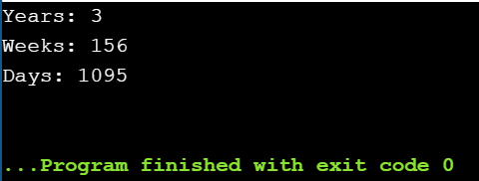

6(c). To check whether a number is even or odd.
#include <stdio.h>
int main()
{
int num;
printf("Enter any number: ");
scanf("%d", &num);
if(num % 2 == 0)
{
printf("Number is Even.");
}
else
{
printf("Number is Odd.");
}
return 0;
}
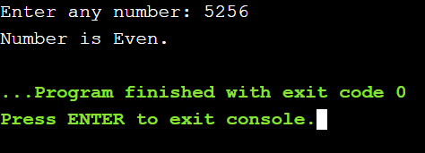

7. To check whether a given year is leap year or not.
#include <stdio.h>
int main()
{
int year;
printf("Enter year : ");
scanf("%d", &year);
if(((year % 4 == 0) && (year % 100 !=0)) || (year % 400==0))
{
printf("LEAP YEAR");
}
else
{
printf("COMMON YEAR");
}
return 0;
}
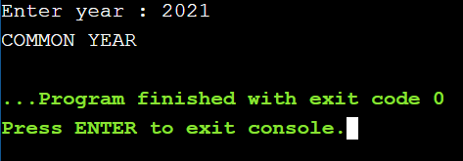

8(a). To check whether a triangle is equilateral, scalene or isosceles.
#include <stdio.h>
int main()
{
int side1, side2, side3;
printf("Enter three sides of triangle: ");
scanf("%d%d%d", &side1, &side2, &side3);
if(side1==side2 && side2==side3)
{
printf("Equilateral triangle.");
}
else if(side1==side2 || side1==side3 || side2==side3)
{
printf("Isosceles triangle.");
}
else
{
printf("Scalene triangle.");
}
return 0;
}
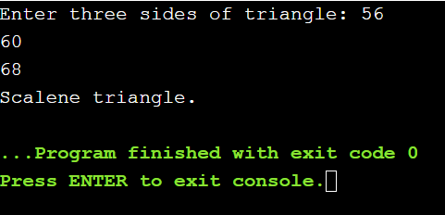

8(b). To check whether a triangle is right triangle, obtuse, acute angles.
#include <stdio.h>
int main()
{
int x,y,z;
printf("Type in the integer lengths of 3 sides of a triangle:\n");
scanf("%d %d %d", &x, &y, &z);
if((x<=0) || (y<=0) || (z<=0)) {
printf("This is not a triangle.\n");
} else {
if((x + y <= z) || (x + z <= y) || (y + z <= x)) {
printf("This is not a triangle.\n");
} else
{
if( ((x * x) + (y * y) == (z * z)) || ((x * x) + (z * z) == (y * y)) || ((z * z) + (y * y) == (x * x)) ) {
printf("This is a right-angled triangle.\n");
} else if( ( ((x * x) + (y * y) < (z * z)) || ((x * x) + (z * z) < (y * y)) || ((z * z) + (y * y) < (x * x)) ) || ( ( x<=z && y<=z ) || ( x<=y && z<=y ) || ( y<=x && z<=x ) ) ) {
printf("This is an acute-angled triangle.\n");
} else if( ( ((x * x) + (y * y) > (z * z)) || ((x * x) + (z * z) > (y * y)) || ((z * z) + (y * y) > (x * x)) ) || ( ( x>z && y>z ) || ( x>y && z>y ) || ( y>x && z>x ) ) ) {
printf("This is an obtuse-angled triangle.\n");
} else {
printf("Not a triangle\n");
}
}
}
return 0;
}
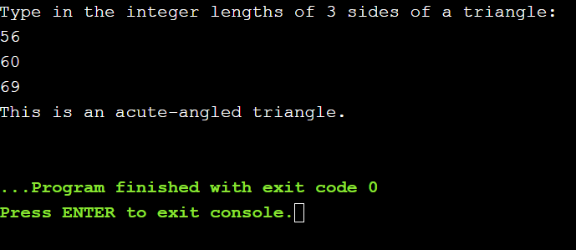

9. To convert temp. from Fahrenheit to Celsius and Celsius to Fahrenheit.
#include <stdio.h>
int main()
{
float celsius, fahrenheit;
printf("Enter temperature in Fahrenheit: ");
scanf("%f", &fahrenheit);
celsius = (fahrenheit - 32) * 5 / 9;
printf("%.2f Fahrenheit = %.2f Celsius", fahrenheit, celsius);
printf("\nEnter temperature in Celsius: ");
scanf("%f", &celsius);
fahrenheit = (celsius * 9 / 5) + 32;
printf("%.2f Celsius = %.2f Fahrenheit", celsius, fahrenheit);
return 0;
}
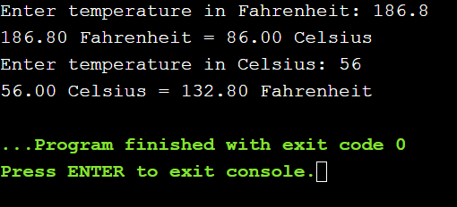

10(a). To check whether a character is an alphabet, digit or special character.
#include <stdio.h>
int main()
{
char ch;
printf("Enter any character: ");
scanf("%c", &ch);
if((ch >= 'a' && ch <= 'z') || (ch >= 'A' && ch <= 'Z'))
{
printf("'%c' is alphabet.", ch);
}
else if(ch >= '0' && ch <= '9')
{
printf("'%c' is digit.", ch);
}
else
{
printf("'%c' is special character.", ch);
}
return 0;
}
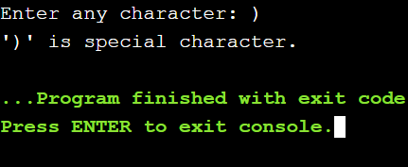

10(b). To check whether an alphabet is vowel or consonant.
#include <stdio.h>
int main()
{
char ch;
printf("Enter any character: ");
scanf("%c", &ch);
if(ch=='a' || ch=='e' || ch=='i' || ch=='o' || ch=='u' ||
ch=='A' || ch=='E' || ch=='I' || ch=='O' || ch=='U')
{
printf("'%c' is Vowel.", ch);
}
else if((ch >= 'a' && ch <= 'z') || (ch >= 'A' && ch <= 'Z'))
{
printf("'%c' is Consonant.", ch);
}
else
{
printf("'%c' is not an alphabet.", ch);
}
return 0;
}
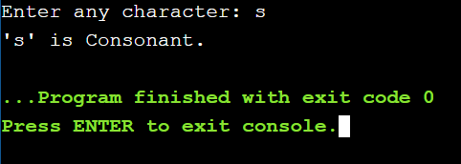

11(a). To find smallest of 2 numbers.
#include <stdio.h>
int main()
{
int a, b, small;
printf("Enter any two number: ");
scanf("%d%d", &a, &b);
if(a<b)
small=a;
else
small=b;
printf("\nSmallest of the two number is: %d", small);
return 0;
}
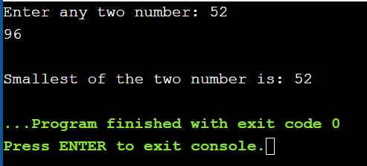

11(b). To find largest of 3 numbers.
#include <stdio.h>
int main()
{
int A, B, C;
printf("Enter the numbers A, B and C: ");
scanf("%d %d %d", &A, &B, &C);
if (A >= B && A >= C)
printf("%d is the largest number.", A);
if (B >= A && B >= C)
printf("%d is the largest number.", B);
if (C >= A && C >= B)
printf("%d is the largest number.", C);
return 0;
}
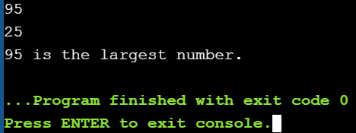

12. To implement simple calculator.
#include <stdio.h>
int main()
{
char Operator;
float num1, num2, result = 0;
printf("Please Enter an Operator (+, -, *, /) : ");
scanf("%c", &Operator);
printf("\nPlease Enter the Values for two Operands: num1 and num2 : ");
scanf("%f%f", &num1, &num2);
switch(Operator)
{
case '+':
result = num1 + num2;
break;
case '-':
result = num1 - num2;
break;
case '*':
result = num1 * num2;
break;
case '/':
result = num1 / num2;
break;
default:
printf("\nYou have enetered an Invalid Operator ");
}
printf("\nThe result of %.2f %c %.2f = %.2f", num1, Operator, num2, result);
return 0;
}

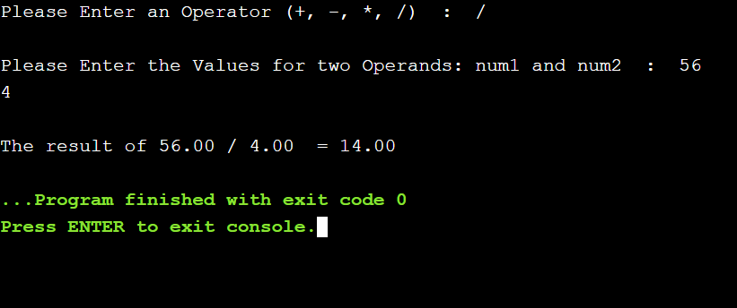

13. To calculate the root of a quadratic equation.
#include <stdio.h>
#include <math.h>
int main()
{
float a, b, c, discriminant, root1, root2;
printf("Enter coefficient of x^2: ");
scanf("%f", &a);
printf("Enter coefficient of x: ");
scanf("%f", &b);
printf("Enter constant term: ");
scanf("%f", &c);
discriminant = sqrt( b*b - 4*a*c );
if(discriminant >= 0)
{
root1 = ( -b + discriminant ) / (2.0*a);
root2 = ( -b - discriminant ) / (2.0*a);
printf("\nFirst root: %.2f\n", root1);
printf("Second root: %.2f\n", root2);
}
else
{
printf("\nRoots are imaginary");
}
return 0;
}
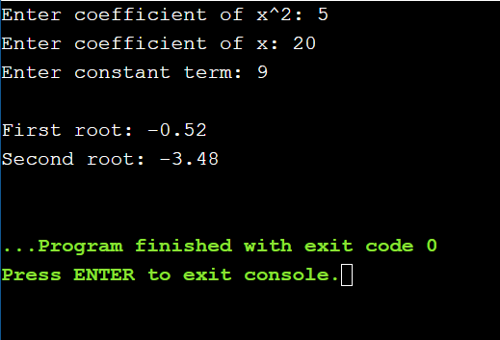

14. To accept a coordinate point in a XY coordinate system and determine in which quadrant the point lies.
#include <stdio.h>
int main()
{
int co1,co2;
printf("Input the values for X and Y coordinate : ");
scanf("%d %d",&co1,&co2);
if( co1 > 0 && co2 > 0)
printf("The coordinate point (%d,%d) lies in the First quandrant.\n",co1,co2);
else if( co1 < 0 && co2 > 0)
printf("The coordinate point (%d,%d) lies in the Second quandrant.\n",co1,co2);
else if( co1 < 0 && co2 < 0)
printf("The coordinate point (%d, %d) lies in the Third quandrant.\n",co1,co2);
else if( co1 > 0 && co2 < 0)
printf("The coordinate point (%d,%d) lies in the Fourth quandrant.\n",co1,co2);
else if( co1 == 0 && co2 == 0)
printf("The coordinate point (%d,%d) lies at the origin.\n",co1,co2);
return 0;
}
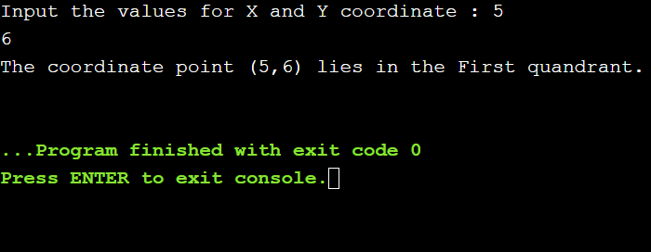

15. To find gross salary of an employee if DA is 40% of basic salary and HRA is 20% of basic salary.
#include <stdio.h>
int main()
{
float bs, hra, da, gs;
printf("Enter basic salary\n");
scanf("%f", &bs);
hra = bs * (20/100.00);
da = bs * (40/100.00);
gs = bs + hra + da;
printf("Gross Salary = %f\n", gs);
return 0;
}
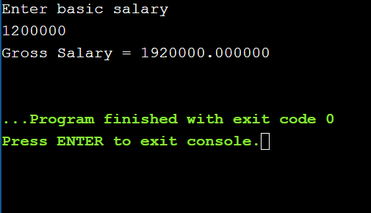

16. To calculate and print the electricity bill of a given costumer.
#include <stdio.h>
int main()
{
int custid, conu;
float chg, surchg=0, gramt,netamt;
char connm[25];
printf("Input Customer ID :");
scanf("%d",&custid);
printf("Input the name of the customer :");
scanf("%s",connm);
printf("Input the unit consumed by the customer : ");
scanf("%d",&conu);
if (conu <200 )
chg = 1.20;
else if (conu>=200 && conu<400)
chg = 1.50;
else if (conu>=400 && conu<600)
chg = 1.80;
else
chg = 2.00;
gramt = conu*chg;
if (gramt>300)
surchg = gramt*15/100.0;
netamt = gramt+surchg;
if (netamt < 100)
netamt =100;
printf("\nElectricity Bill\n");
printf("Customer IDNO :%d\n",custid);
printf("Customer Name :%s\n",connm);
printf("unit Consumed :%d\n",conu);
printf("Amount Charges @Rs. %4.2f per unit :%8.2f\n",chg,gramt);
printf("Surchage Amount :%8.2f\n",surchg);
printf("Net Amount Paid By the Customer :%8.2f\n",netamt);
return 0;
}
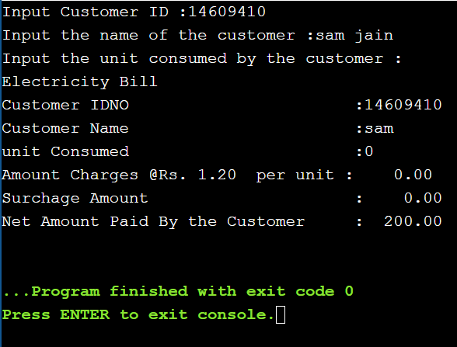

17. To accept the number of days the member is late to return the book .
#include <stdio.h>
int main()
{
int days;
float fine;
printf("Enter the number of days: ");
scanf("%d", &days);
if (days > 0 && days <= 5)
fine = 0.50 * days;
if (days >= 6 && days <= 10)
fine = 1 * days;
if (days > 10)
fine = 5 * days;
if (days > 30)
{
printf("Your membership would be canceled.\n");
}
printf("You have to pay Rs. %.2f fine.", fine);
return 0;
}

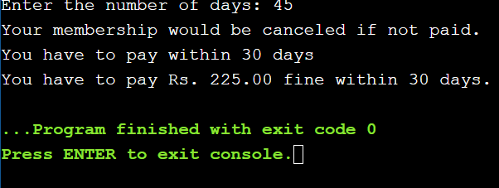

18. To find the factorial of any number.
#include <stdio.h>
int main()
{
int i,fact=1,a;
printf("Enter a number: ");
scanf("%d",&a);
for(i=1;i<=a;i++)
{
fact=fact*i;
}
printf("Factorial of %d is: %d",a,fact);
return 0;
}
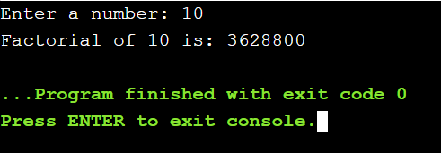

19. To print Fibonacci sequence.
#include<stdio.h>
int main()
{
int n1=0,n2=1,n3,i,number;
printf("Enter the number of elements:");
scanf("%d",&number);
printf("\n%d %d",n1,n2);
for(i=2;i<number;++i)
{
n3=n1+n2;
printf(" %d",n3);
n1=n2;
n2=n3;
}
return 0;
}
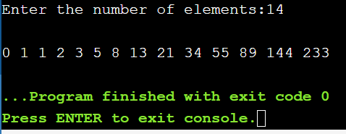

20. To accept an integer and find sum of digits.
#include <stdio.h>
int main()
{
int n, t, sum = 0, remainder;
printf("Enter an integer\n");
scanf("%d", &n);
t = n;
while (t != 0)
{
remainder = t % 10;
sum = sum + remainder;
t = t / 10;
}
printf("Sum of digits of %d = %d\n", n, sum);
return 0;
}
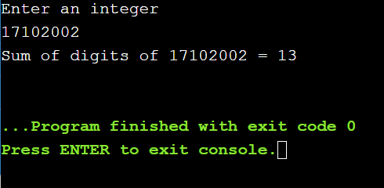

21. To accept an integer and find reverse of this number and check this number for palindrome.
#include <stdio.h>
int main()
{
int n, reversedN = 0, remainder, originalN;
printf("Enter an integer: ");
scanf("%d", &n);
originalN = n;
while (n != 0) {
remainder = n % 10;
reversedN = reversedN * 10 + remainder;
n /= 10;
}
if (originalN == reversedN)
printf("%d is a palindrome.", originalN);
else
printf("%d is not a palindrome.", originalN);
return 0;
}

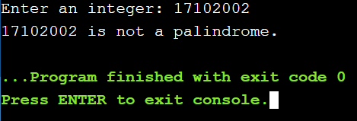

22. To check a number is amstrong or not.
#include <stdio.h>
int main()
{
int num, originalNum, remainder, result = 0;
printf("Enter a three-digit integer: ");
scanf("%d", &num);
originalNum = num;
while (originalNum != 0)
{
remainder = originalNum % 10;
result += remainder * remainder * remainder;
originalNum /= 10;
}
if (result == num)
printf("%d is an Armstrong number.", num);
else
printf("%d is not an Armstrong number.", num);
return 0;
}
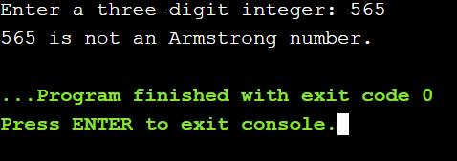

23. To check a number is perfect or not.
#include <stdio.h>
int main()
{
int i, num, sum = 0;
printf("Enter any number to check perfect number: ");
scanf("%d", &num);
for(i = 1; i <= num / 2; i++)
{
if(num%i == 0)
{
sum += i;
}
}
if(sum == num)
{
printf("%d is PERFECT NUMBER", num);
}
else
{
printf("%d is NOT PERFECT NUMBER", num);
}

return 0;
}

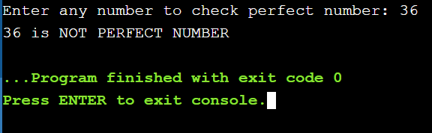

24. To find the sum of series:

S=2+4+6+8+…………….N terms.
#include <stdio.h>
int main()
{
int i,n;
int sum_of_series = 0;
printf("\n C Program to print sum of series 2 + 4 + 6 + 8 + .... + n : \n\n ");
printf("Enter an even number n : ");
scanf("%d",&n);
for ( i = 1 ; i <= n ; i++ )
{
i = i+1;
if(n!=i)
printf(" %d +",i);
else
printf(" %d ",i);
sum_of_series = sum_of_series + i;
}
printf(" = %d",sum_of_series);
return 0;
}
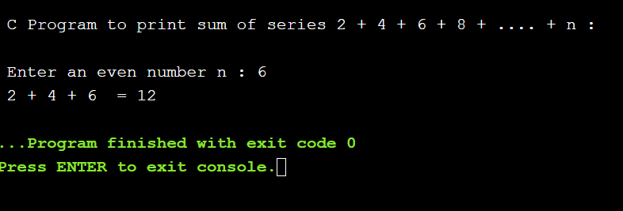

25. To check a number is prime or not.
#include <stdio.h>
int main()
{
int i,n,flag=0;
scanf("%d", &n);
for(i=1;i<n;i++)
{
if(n%1==0)
{
flag=flag+1 ;
}
}
if(flag==2)
{
printf("It is a prime number");
}
else
{
printf("It is not a prime number");
}
return 0;
}

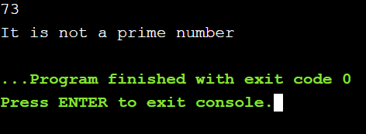

26. To find sum of Series:

1 + 1/2 + 1/3 + 1/4 + 1/5 …….. N.
#include <stdio.h>
int main()
{
int num,i,sum=0;
printf("Input any number: ");
scanf("%d",&num);
printf("1 + ");
for(i=2;i<=num-1;i++)
printf(" 1/%d +",i);
for(i=1;i<=num;i++)
sum = sum + i;
printf(" 1/%d",num);
printf("\nSum = 1/%d",sum+1/num);
return 0;
}

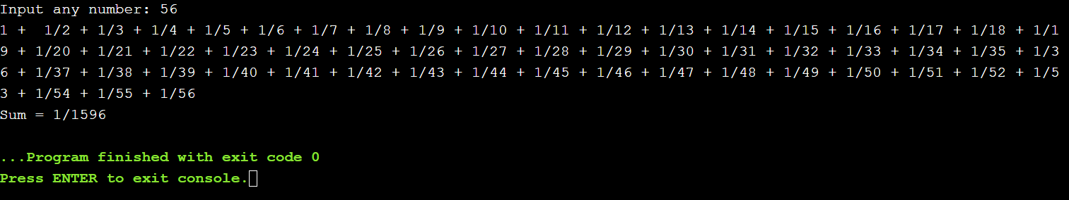

27. To find sum of series:

1! + 2! + 3! + 4! ....................... n! .
#include <stdio.h>
int main()
{
int i,N,fact=1;
float sum;
printf("Enter the value of N: ");
scanf("%d",&N);
sum=0;
for(i=1;i<=N;i++)
{
fact=fact*i;
}
for(i=1;i<=N;i++)
sum = sum + fact*i;
printf("Sum of the series is: %f\n",sum);
return 0;
}

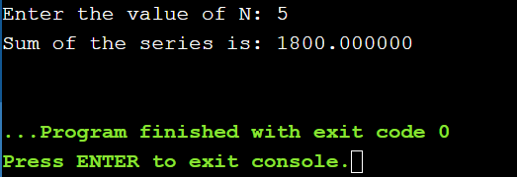

28. To find sum of series:

S=1^3 + 2^3 + 3^3 + 4^3 ……. N terms.
#include <stdio.h>
int main()
{
int i,N;
unsigned long sum;
printf("Enter the value of N: ");
scanf("%d",&N);
sum=0;
for(i=1;i<=N;i++)
sum= sum+ (i*i*i);
printf("Sum of the series is: %ld\n",sum);
return 0;
}
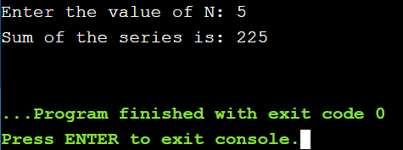

29. To find sum of series:

S=1/1! + 2/2! + 3/3! ……….. 7th term.
#include <stdio.h>
int main()
{
int num = 1, count;
float sum = 0.0, fact;
while(num <= 7)
{
fact = 1;
for(count = 1; count <= num; count++)
{
fact = fact * count;
}
sum = sum + (num / fact);
num++;
}
printf("Sum of series is %f\n", sum);
return 0;
}
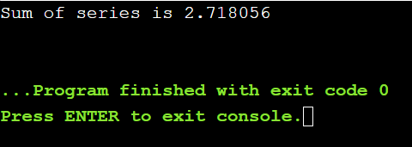

30. To convert binary number to decimal number.
#include <stdio.h>
int main()
{
int n1, n;
int dec=0,i=0,j,d;
printf("Input the binary number :");
scanf("%d",&n);
n1=n;
while(n!=0)
{ d = n % 10;
dec=dec+d*pow(2,i);
n=n/10;
i++;
}
printf("The equivalent Decimal Number is : %d\n",dec);
return 0;
}
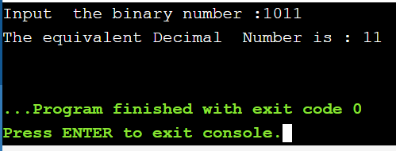

31. To find sum of series:

S=1^4 + 2^4 + 3^4 ………. 100th term.
#include <stdio.h>
int main()
{
int i,N=100;
unsigned long sum;
printf("Enter the value of N: ");
scanf("%d",&N);
sum=0;
for(i=1;i<=N;i++)
sum= sum+ (i*i*i*i);
printf("Sum of the series is: %ld\n",sum);
return 0;
}
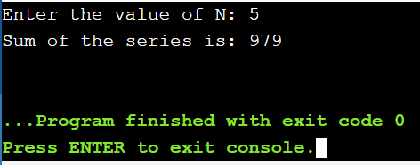

32. To print the pattern:

* * *

* * *

* * *
#include <stdio.h>
int main()
{
int n;
for(int i=0;i<3;i++)
{
for(int j=0;j<3;j++)
{
printf("*");
}
printf("\n");
}
return 0;
}
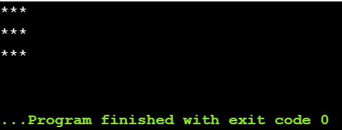

33. To print the pattern:

1 2 3

1 2 3

1 2 3
#include <stdio.h>
int main()
{
int i, j;
for(i=1;i<=3;i++)
{
for(j=1;j<=3;j++)
printf("%d",j);
printf("\n");
}
return 0;
}
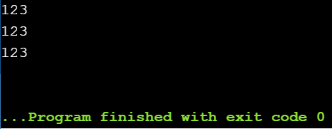

34. To print the pattern:

1 1 1

2 2 2

3 3 3
#include <stdio.h>
int main()
{
int i, j;
for(i=1;i<=3;i++)
{
for(j=1;j<=3;j++)
printf("%d",i);
printf("\n");
}
return 0;
}
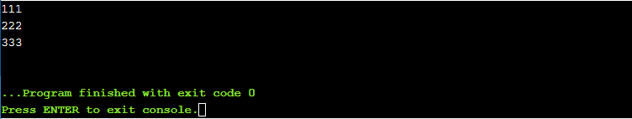

35. To print the pattern:

3 2 1

3 2 1

3 2 1
#include <stdio.h>
int main()
{
int i, j;
for(i=3;i>=1;i--)
{
for(j=3;j>=1;j--)
printf("%d",j);
printf("\n");
}
return 0;
}

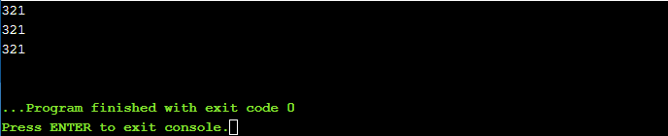

36. To print the pattern:

3 3 3

2 2 2

1 1 1
#include <stdio.h>
int main()
{
int i, j;
for(i=3;i>=1;i--)
{
for(j=3;j>=1;j--)
printf("%d",i);
printf("\n");
}
return 0;
}
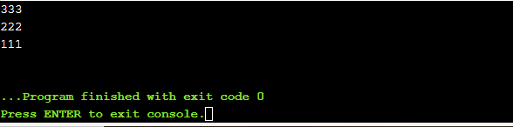

37. To print the pattern:

*

* *

* * *
#include <stdio.h>
int main()
{
int n;
for(int i=1;i<=3;i++)
{
for(int j=1;j<=i;j++)
{
printf("* ");
}
printf("\n");
}
return 0;
}

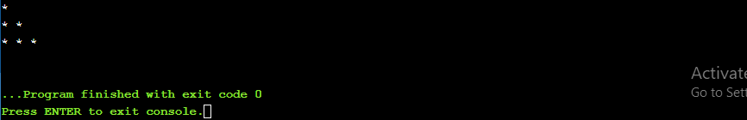

38. To print the pattern:

1

1 2

1 2 3
#include <stdio.h>
int main()
{
int i, j;
for (i = 1; i <= 3; ++i)
{
for (j = 1; j <= i; ++j)
{
printf("%d ", j);
}
printf("\n");
}
return 0;
}
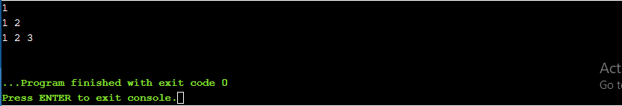

39. To print the pattern:

1

2 2

3 3 3
#include <stdio.h>
int main()
{
int i, j;
for(i=1; i<=3; i++)
{
for(j=1; j<=i; j++)
{
printf("%d", i);
}
printf("\n");
}
return 0;
}
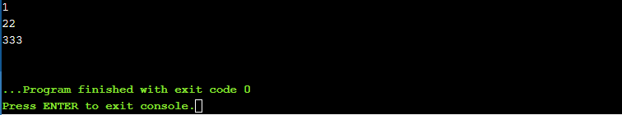

40. To print the pattern:

3

3 2

3 2 1
#include <stdio.h>
int main()
{
int i, j;
for (i = 3; i >= 1; i--)
{
for (j = 3; j >= i; j--)
{
printf("%d ", j);
}
printf("\n");
}
return 0;
}
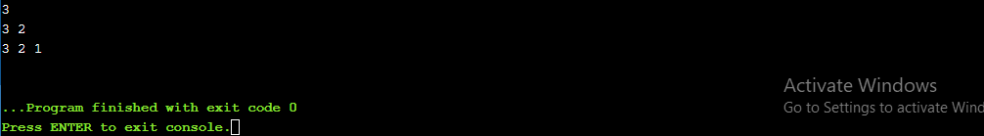

41. To print the pattern:

3

2 2

1 1 1
#include <stdio.h>
int main()
{
int i, j;
for(i=3; i>=1; i--)
{
for(j=3; j>=i; j--)
{
printf("%d", i);
}
printf("\n");
}
return 0;
}
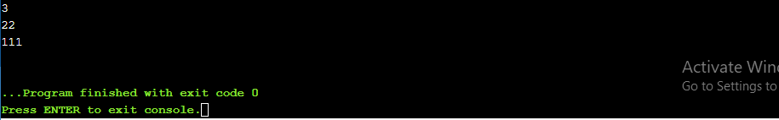

42. To print the pattern:

*

* * *

* * * * *

* * * * * * *
#include <stdio.h>
int main()
{
int i, space, k = 0;
for (i = 1; i <= 4; ++i, k = 0)
{
for (space = 1; space <= 4 - i; ++space)
{
printf(" ");
}
while (k != 2 * i - 1)
{
printf(" * ");
++k;
}
printf("\n");
}

return 0;
}
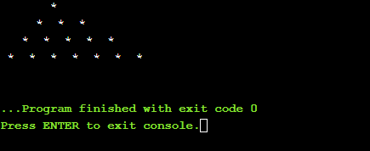

43. To print the pattern:

1

1 2 1

1 2 3 2 1

1 2 3 4 3 2 1
#include <stdio.h>
int main()
{
int i,j;
for(i=1;i<=4;i++)
{
for(j=1;j<=4-i;j++)
{
printf(" ");
}
for(j=1;j<=i;j++)
{
printf("%d",j);
}
for(j=i-1;j>=1;j--)
{
printf("%d",j);
}
printf("\n");
}
return 0;
}
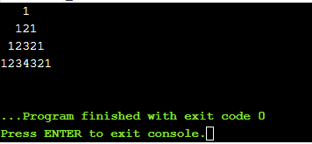

44. To print the pattern:

1

0 1

1 0 1

0 1 0 1
#include <stdio.h>
int main()
{
int i,j;
for(i=0;i<=5;i++)
{
for(j=1;j<i;j++)
{
if((i+j)%2==0)
{
printf("0");
}
else
{
printf("1");
}
}
printf("\n");
}

return 0;
}
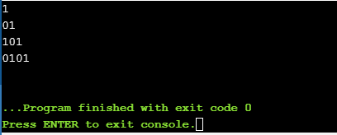

45. To print all prime numbers in a given range.
#include <stdio.h>
int main()
{
int low, high, i, flag;
printf("Enter the intervals: ");
scanf("%d %d", &low, &high);
printf("Prime numbers between %d and %d are: ", low, high);
while (low < high)
{
flag = 0;
if (low <= 1)
{
++low;
continue;
}
for (i = 2; i <= low / 2; ++i)
{
if (low % i == 0)
{
flag = 1;
break;
}
}
if (flag == 0)
printf("%d ", low);
++low;
}
return 0;
}
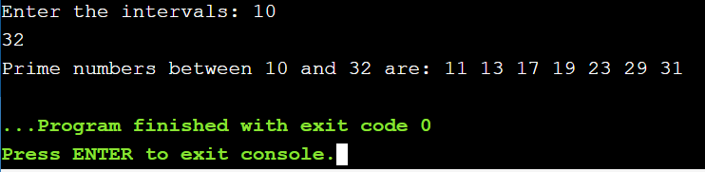

46. To convert decimal number into binary.
#include <stdio.h>
int main()
{
int n, i, j, binno=0,dn;
printf("Enter a number to convert : ");
scanf("%d",&n);
dn=n;
i=1;
for(j=n;j>0;j=j/2)
{
binno=binno+(n%2)*i;
i=i*10;
n=n/2;
}
printf("\nThe Binary conversion of %d is %d.",dn,binno);
return 0;
}

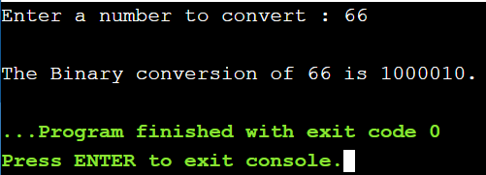

47. To find sum, average, max and min from a list of n numbers.
#include <stdio.h>
int main()
{
int a[8],i,s=0,g,l;
float avg;
printf("Enter 8 Numbers:\n");
for(i=0;i<8;i++)
{
scanf("%d",&a[i]);
s=s+a[i];
avg=s/8.0;
}
printf("Sum of Array Elements = %d\n",s);
printf("Average of Elements = %.2f\n",avg);
g=a[0];
for(i=0;i<8;i++)
if(a[i]>g)
g=a[i];
printf("Greatest Element = %d\n",g);
l=a[0];
for(i=0;i<8;i++)
if(a[i]<l)
l=a[i];
printf("Lowest Element = %d",l);
return 0;
}
